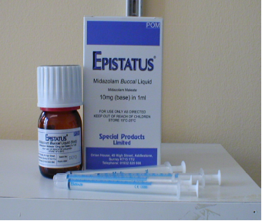
Buccal Midazolam
(10mg/ml)
Parent and Carer’s Information Leaflet and
Care Plan for Children at Risk of Long Seizures (Fits)

Individual Emergency Care Plan for:
Name…………………………….DOB……………………NHS no…………………………………

Description of typical seizure when buccal midazolam ^{n}eeds to be given:

………………………………………………………………………………….................................

When should buccal midazolam ^{b}e given?……………....................................................................

……………………………………………………………………………….....................................

Dose: Give: …...mg of 10mg/ml buccal midazolam. This is equalivalent to .….ml.

Whenever you get a new prescription check that the concentration is 10mg/ml. If it is not please contact us for a new care plan.

Additional Instructions?:……………………….………………………………..........................

………………………………………………………………………………….................................

When to call ambulance?..........................................................................................................

………………………………………………………………………………….................................

Professional’s Name…………......................... Signature……..……………. Date …………

I consent for other trained professionals to administer buccal midazolam as per this care plan.

Parent’s Name………….....................................Signature……..……………. Date …………

For further advice contact your local team:

CEWT websitewww.cewt.org.uk
Epilepsy Action Website: www.epilepsy.org.uk
Young Epilepsywww.youngepilepsy.org.uk

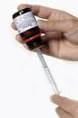
Many seizures will stop on their own. Some seizures need help to stop and may cause problems if they continue too long.

When do I give buccal Midazolam?
As well as this leaflet you should have had training on when and how to give buccal Midazolam for your child. Generally buccal Midazolam may be given when a child or young person with epilepsy has:
- a generalised convulsive seizure lasting more than 5 minutes. (These are seizures where the child does not respond, continues to be stiff and may jerk their arms and legs). OR
- a pattern of convulsive seizures that stop then start again straight away without recovering in between and together go on longer than 5 minutes.
- Some children will have buccal midazolam for individual circumstances and this will be outlined on page 1 of this care plan if appropriate.

How do I store buccal Midazolam?
Buccal Midazolam does not need to be stored in the fridge. Further details about storage can be found in the instruction leaflet supplied with the medication. Keep it out of reach of children. Check the expiry date before using. Ensure you take buccal Midazolam with you if you are going out. School or other carers may also need to keep some and arrange training.

How often can I use it?
When not in hospital, do not use buccal midazolam more than once in any 24 hour period. Some children may have a plan describes more than once. see individual ‘additional instructions’. If the first dose does not work, the ambulance or hospital may give a second dose 10 minutes after the first.
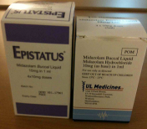
How do I measure the correct dose?
- The buccal Midazolam will come in a bottle with 4 small syringes.
- There are different products available so check you have the correct concentration
- Remove the safety cap from the bottle by pushing down and turning it anti-clockwise.
- Take the syringe and, ensuring the plunger is pushed completely down, push the tip of the syringe into the hole in the top of the bottle.
- Turn the bottle upside down and draw out the amount prescribed by your doctor.
- Turn the bottle upright and remove the syringe.
- It is important to replace the lid on the bottle straight away.
How do I give the buccal Midazolam?
- If possible place your child on their side.
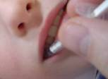
- Place the tip of the syringe between the cheek and gums on the side closest to the floor.
- Once in place, push the plunger down gently to give the medicine.
- If your child is on their back give half the dose slowly in one side and then half in the other.

Does it work straight away?
Buccal Midazolam will take 5 to 10 minutes to work and most children will sleep for a while after the seizure has finished. They should be placed on their side during this time.

Do I need to call ‘999’?
- Generally, if your child has been given the buccal midazolam and is still having a seizure 10 minutes after giving the dose, OR if your child appears to have any difficulty breathing or stops breathing, call 999.
- If the child is needing buccal midazolam for the very first time, some carers may wish to first call 999 and then wait until the ambulance arrives before giving buccal midazolam
- Other parents/carers may wish to call an ambulance straight after giving the dose.

Are there any side effects?
Buccal Midazolam can make your child sleepy or restless. Very rarely it may slow down breathing.

Is it safe to give if my child is taking other medicines?
Yes. But do not give it with rectal diazepam.

Test dose
Professionals may consider a test dose of buccal midazolam for some children where they have not had previous benzodiazepines and there are risk factors for an unexpected reaction.

Disclaimer
Some children have their own individual emergency plan which may differ from this leaflet. If you have any questions, please ask your doctor or specialist nurse. Buccal Midazolam products do not yet have marketing authorisation for this use so cannot be advertised by the manufacturer.

